APP:

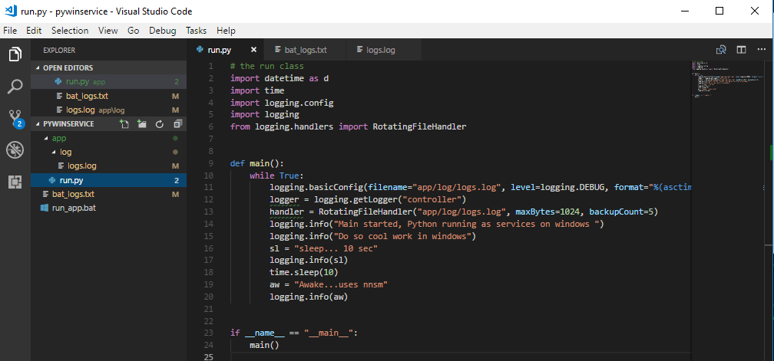

NSSM:

<https://nssm.cc/download>

Download and copy to location

SERVICE:

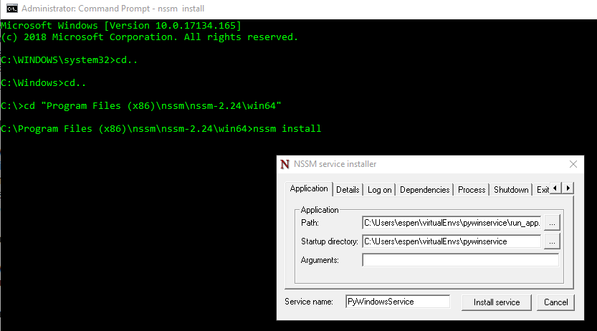

Installed success

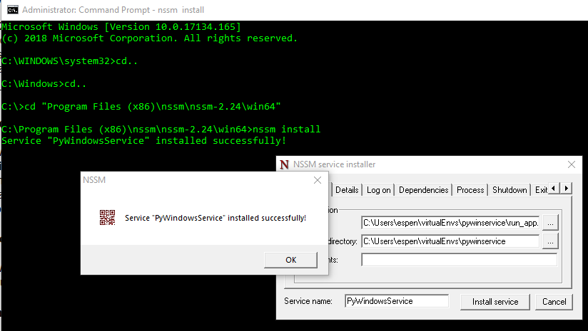

Service

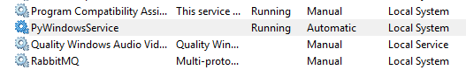

Logs for bat:

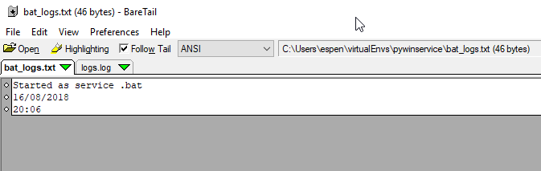

Logs for python app

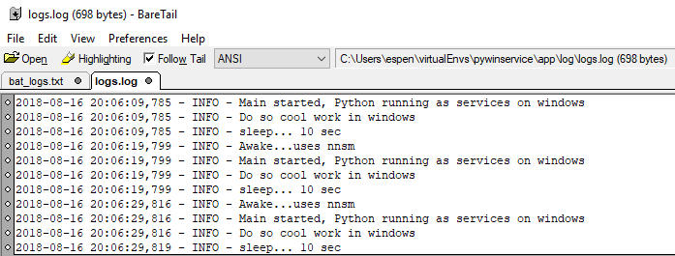

Process / service



Go to service:

